**SME Explanation: HTTP Header Analysis for Hello World RESTful Web Service**

**1. In network tab of developer tools show the HTTP header details received**

When the URL http://localhost:8083/hello is accessed through a web browser like Chrome, the Developer Tools can be used to inspect the HTTP headers. In the **Network** tab, the /hello request appears after the page loads. By clicking on it and opening the **Headers** section, we can view both the **Request Headers** and the **Response Headers**. The request headers show how the browser sent the request, including fields like GET /hello HTTP/1.1, Host: localhost:8083, and User-Agent, which identifies the browser. The response headers confirm that the server returned a successful 200 OK response and include Content-Type: text/plain;charset=UTF-8, which means the response is in plain text format, and Content-Length: 13, showing the size of the string “Hello World!!”.

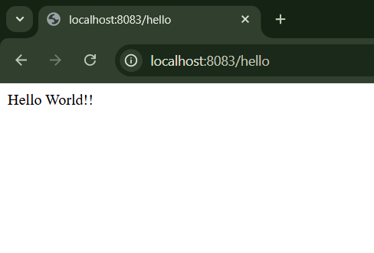

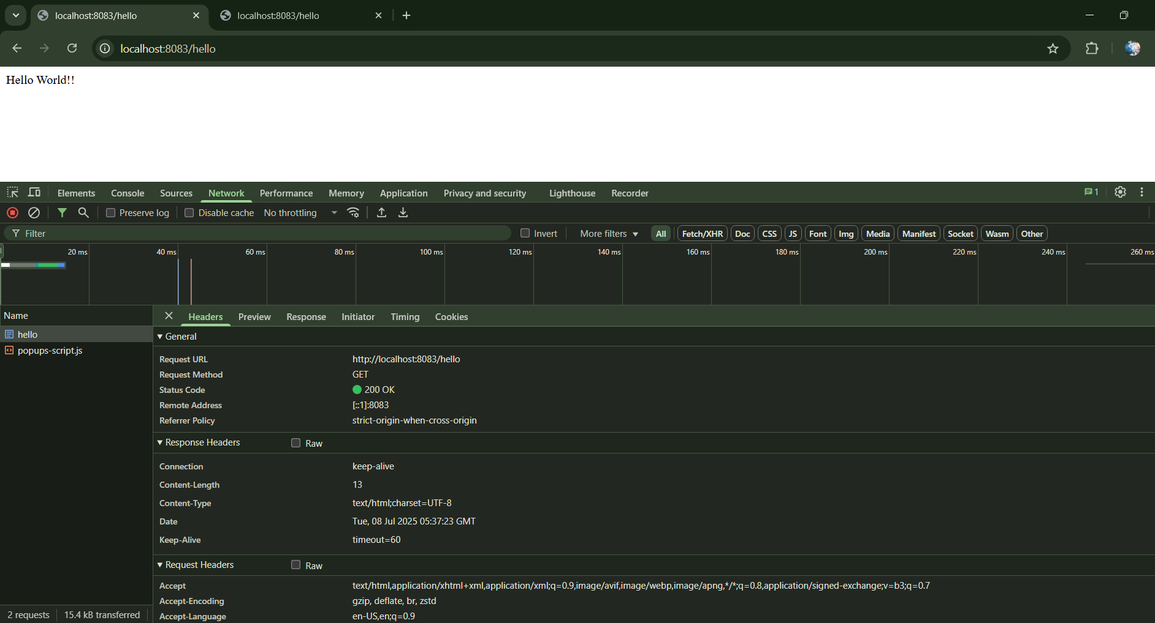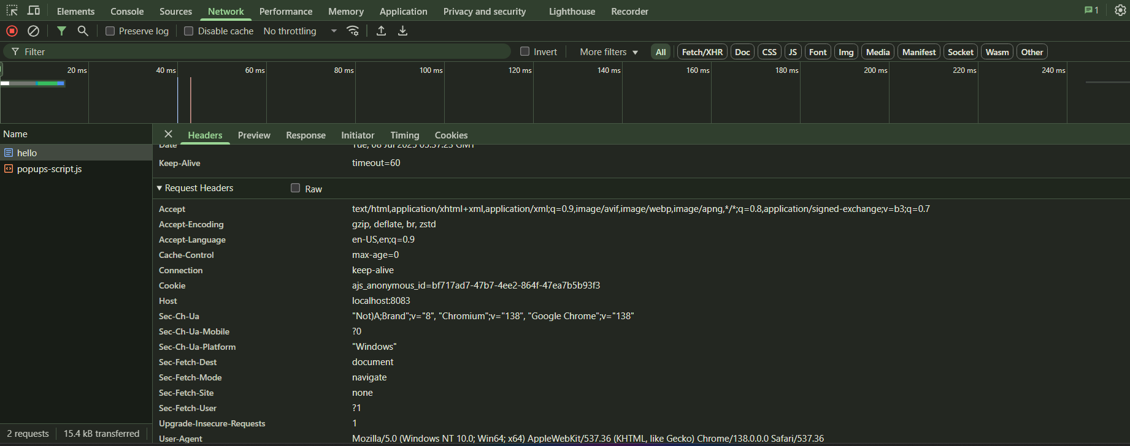

**2. In Postman click on "Headers" tab to view the HTTP header details received**

When the same GET request is sent using Postman to http://localhost:8083/hello, the response is displayed in the Body section. To view the HTTP headers, the **Headers** tab under the **Response** section must be clicked. This reveals the same HTTP metadata as seen in the browser, including Content-Type: text/plain;charset=UTF-8, which shows that the response is in plain text, Content-Length: 13, and other standard headers like Date and Connection. These headers verify that the Spring Boot RESTful service responded correctly with the expected output, and the API works as intended.

